Local Workforce Development Board
Area #40
5367 I-49 S. Service Rd.
Opelousas, Louisiana 70570
Phone: (337) 942.5678 Fax: (337) 942.9654
www.acadianaworkforce.org
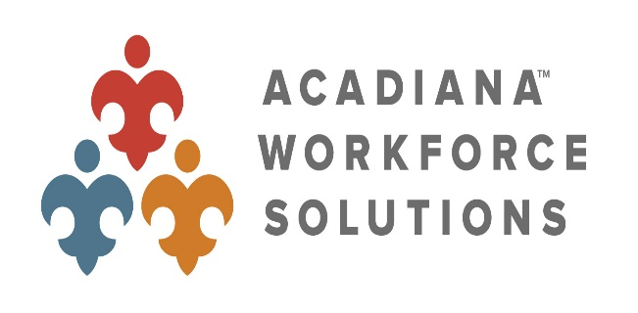

TENTATIVE AGENDA
LWDB #40 BOARD OF DIRECTOR’S MEETING
SPECIAL SESSION MEETING JULY 28, 2021 – 10:00 AM
via Zoom

- CALL MEETING TO ORDER
- PLEDGE OF ALLEGIANCE
- ROLL CALL
- WELCOME

- MINUTES FROM PREVIOUS MEETINGS (ACTION)

- FINANCE COMMITTEE REPORT (ACTION)
- UPCOMING EVENTS/UPDATES/REMINDERS
- NEW BUSINESS
- OTHER BUSINESS
- PUBLIC COMMENT
- ADJOURN (ACTION)

